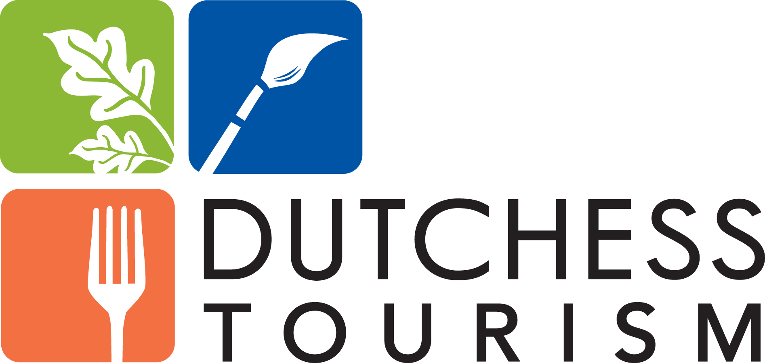
Tourism News

For Immediate Release, July 25, 2017
Contact: Nancy Lutz, 845-463-5446
Nancy@dutchesstourism.com
New Report Shows Tourist Spending Up Again in Dutchess
POUGHKEEPSIE, NY– Tourism Economics, an Oxford Economics Company, recently released their report “The Economic Impact of Tourism in New York” which showed 2016 tourism spending in Dutchess County increased 7.6% over 2015 to more than $568 million. This is the seventh consecutive year spending has increased and the one with the largest annual jump.
Tourism continues to be a major economic driver for Dutchess County. More than 4.75 million people visit the county annually, and, in addition to spending more than half a billion dollars on lodging, dining, shopping, area attractions and transportation, generated $40.9 million in local taxes and $31.7 million for New York State. Were it not for tourism-generated state and local taxes, the average household in Dutchess County would have to pay an additional $678 to maintain the same level of government services.
Dutchess Tourism, Inc. (DTI), an independent 501c6 non-profit organization, is the officially designated destination marketing organization for Dutchess County. DTI President & CEO Mary Kay Vrba said, "Visitors from around the state, nation and world are discovering our Distinctly Dutchess attractions and are drawn to our one-of-a-kind experiences.” Vrba, who was recently named an Outstanding Woman in Destination Management/Marketing by Women in Travel and Tourism International, added, “Our promotional efforts not only support the world-renowned attractions and historic landmarks, but also many small businesses. We know our marketing efforts are vital to making the cash registers ring at B&BS, restaurants, shops, farms and recreation sites. We are committed to helping support these businesses, the backbone of our local communities.”
Tourism is New York’s fourth largest industry and employs 10,484 people within Dutchess County. “As an industry, employer and economic engine, tourism continues to grow,” said Dutchess County Executive Marcus J. Molinaro. “Our partnership with Dutchess Tourism, Inc. continues to create jobs, improve our economy and increase revenues. I applaud Dutchess Tourism, Mary Kay Vrba and all those helping to tell our story and promote all that makes us a great place to visit and enjoy.”
Tourism is a significant driver to the local, state and US economy, returning $8 for every $1 invested. To attract visitors to the county, DTI utilizes a multi-pronged marketing sapproach to help spread the
word about Dutchess’ tourism assets. This includes digital, print and television advertising, primarily in the New York City-metro area as well as ads in national magazines and international publications. DTI is also active on social media attracting thousands of followers across all the major platforms and produces videos to highlight events as well as experiences. Most recently, their Dutchess Craft Beverage video won a 2016 SIAA gold award. In the first half of 2017, there were 567,675 visitors, including 183,577 international, to their web site: DutchessTourism.com. DTI also prints and distributes 90,000 copies of their free Dutchess County Travel Guide annually, along with a number of other publications, which are available by request online.
ABOUT DUTCHESS TOURISM, INC.
The DTI office is located at 3 Neptune Road in the Town of Poughkeepsie with 19 Tourism Information Centers located around Dutchess County. Their website is www.DutchessTourism.com and they can be reached at 845-463-4000. Follow Dutchess Tourism on Twitter, Facebook, Instagram, Pinterest and YouTube. Dutchess County Tourism was founded in 1984 under the umbrella of the Dutchess County Economic Development Corporation, became incorporated as Dutchess Tourism, Inc. in 2014 and is partially funded by monies received from the County of Dutchess.

