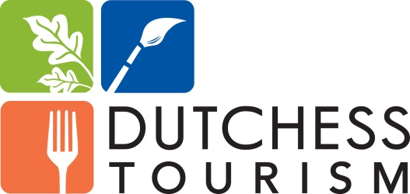

The Dutchess Tourism
Awards of Distinction Finalists
The winners were announced at the May 8th Celebration.

The Dutchess County Executive’s Award for Overall Distinction
- Bard College - winner
- The Culinary Institute of America
- Franklin D. Roosevelt Presidential Library & Museum

Arts Award of Distinction
- Beacon Arts/Second Saturdays
- The Moviehouse
- The Wassaic Project - winner

Culinary Award of Distinction
- Hyde Park Brewing Company - winner
- Indoor Organic Gardens of Poughkeepsie
- Terrapin

Family Entertainment Award of Distinction
- Bounce! Trampoline Sports
- Four Brothers Drive-In Theater
- Harlem Valley Farm & Food Alliance - winner
Brookby Farm, Hoofprint Cheese Company, JSK Cattle Company, Locust Hill Market & Soukup Farms

History Award of Distinction
- Bannerman’s Castle
- Beekman Arms
- Old Rhinebeck Aerodrome - winner

Outdoors Award of Distinction
- Formal Gardens at Vanderbilt Mansion - winner
- James Baird State Park
- Norrie Point Paddlesport Center

Hospitality Award of Distinction
- Paige Flori, Boutique Wines, Spirits & Cider
- Sabrina Kardas, Hampton Inn Fishkill - winner
- Scott Koster, Millbrook Vineyards & Winery

